**Task 8**

8. Keeping Components Pure

Tasks:

1. Convert an impure component that uses Math.random() within the render

phase to a pure one.

**Pure.jsx**

import { useState,useEffect } from 'react'

export default function Pure() {

const [randomNumber,setRandomNumber] = useState(0)

useEffect(() => {

setRandomNumber(Math.random())

},[]);

return (

<>

<p>Random Number: {randomNumber}</p>

</>

)

}

**Impure.jsx**

import React from 'react'

export default function Impure() {

return (

<>

<p>{Math.random()}</p>

</>

)

}

**Main.jsx**

import Pure from './Pure.jsx'

import Impure from './Impure.jsx'

createRoot(document.getElementById('root')).render(

<StrictMode>

<Impure />

<Pure />

</StrictMode>

)

**Output**

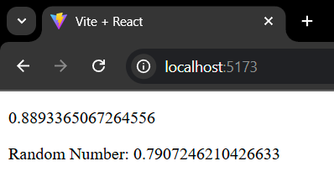

2. Create a pure component Clock that displays the current time and updates

every second without causing side-effects during the render phase.

**Clock.jsx**

import React, { useEffect, useState } from 'react'

export default function Clock() {

const [time,setTime] = useState(new Date());

useEffect(()=> {

const timer = setInterval(()=>setTime(new Date()),1000);

return () => clearInterval(timer);

},[]);

return (

<>

<h3>Time: {time.toLocaleTimeString()}</h3>

</>

)

}

3. Use Strict Mode in an existing application and identify any warnings in the

console.

**Main.jsx**

import Clock from './Clock.jsx'

createRoot(document.getElementById('root')).render(

<StrictMode>

<Clock />

</StrictMode>

)

**Output**

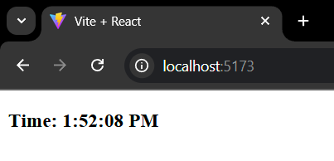

4. Convert a class-based component with side effects in its lifecycle methods

to a pure functional component using hooks.

**Class Component**

import React , {Component} from 'react'

class Counter extends Component {

constructor(props){

super(props);

this.state = {count:0};

}

Increment=() => {

this.setState({count: this.state.count+1})

}

render(){

return(

<>

<h2>Count: {this.state.count}</h2>

<button onClick={this.Increment}>Increase</button>

</>

)

}

}

export default Counter

**Functional Component**

import React, { useState } from 'react'

export default function Counter() {

const [count,setCount] = useState(0);

return (

<>

<h2>Count: {count}</h2>

<button onClick={()=>setCount(count+1)}>Increase</button>

</>

)

}

5. Make a pure ProfilePic component that takes a user ID as a prop and fetches

the user’s profile picture URL from an array without side-effects during

rendering.

**ProfilePic.jsx**

import React from 'react'

export default function ProfilePic(props) {

const users = [

{id:1,profile:"https://encrypted-tbn0.gstatic.com/images?q=tbn:ANd9GcQyCixyM2urliFC1w0DyNMJpBRMOXFizr3FR8aRIFfcDUGBzEaXcV6mt4gVWRqGAqqu4PI&usqp=CAU"},

{id:2,profile:"https://encrypted-tbn0.gstatic.com/images?q=tbn:ANd9GcQQ-Bx4bcOTMKU5bQLVsa5gLWVLWK6blo_r06U9C-ZeJCGkQAwQJ2R1knRcfKrJSO5zpQc&usqp=CAU"}

]

const user = users.find(u => u.id === props.userid)

return (

<>

{user ?(

<div>

<h1>UserId: {props.userid}</h1>

<img src={user.profile}></img>

</div>

):

(<p>No user Found</p>)}

</>

)

}

**Main.jsx**

import ProfilePic from './ProfilePic.jsx'

createRoot(document.getElementById('root')).render(

<StrictMode>

<ProfilePic userid={1} />

<ProfilePic userid={2} />

<ProfilePic userid={3} />

</StrictMode>

)

**Output**

